|  |  |  |  |  |  |  |  |  |  |  |  |  |  |  |  |  |  |  |  |  |  |  |  |  |  |  |  |  |  |  |  |  |  |  |  |  |  |  |  |  |  |  |  |  |  |  |  |
| --- | --- | --- | --- | --- | --- | --- | --- | --- | --- | --- | --- | --- | --- | --- | --- | --- | --- | --- | --- | --- | --- | --- | --- | --- | --- | --- | --- | --- | --- | --- | --- | --- | --- | --- | --- | --- | --- | --- | --- | --- | --- | --- | --- | --- | --- | --- | --- |
| USA Today article #1  From 10/26/11  Tuition and fees rise more than 8% at U.S. public colleges    *Tuition and fees at America's public colleges rose more than 8% this year as a weakened economy and severe cuts in state funding took their toll, a report out today says.*  Public four-year universities charged residents an average of $8,244, up 8.3% from last year, while public two-year schools charged an average of $2,963, up 8.7%, says the report by the non-profit [College Board](http://content.usatoday.com/topics/topic/Organizations/Non-profits,+Activist+Groups/College+Board). About 80% of the nation's undergraduates attend public institutions.  That increase is more than double the inflation rate of 3.6% between July 2010 and July 2011. Family earnings dropped across all income levels. And state funding per student declined by 4% in 2010, the latest year available, and 23% over the past decade, the report says.  Molly Corbett Broad, president of the [American Council on Education](http://content.usatoday.com/topics/topic/Organizations/Non-profits,+Activist+Groups/American+Council+on+Education), called the findings "sadly familiar," and said the drop in state support was particularly troubling. "It has become all too common for state legislatures to dip into the pockets of students and families to balance state budgets," she says.  The tuition and fee hike is not the worst of the decade — that occurred in 2004, when sticker prices rose 11% beyond inflation from the previous year.  The report says there may be some good news: a rise in federal student aid — including tax credits and deductions — is blunting the impact for most families. "At a time when students and families are ill-equipped to manage additional expenses, student financial aid is more important than ever," report author Sandy Baum says.  Net price — the published price minus grants and tax breaks — at public four-year colleges averaged $2,490, the report found.  About two-thirds of undergraduates receive grant aid, which averaged $6,539 last year. Average federal loans averaged $4,907. Borrowing by students and parents increased about 2% from 2009-10 to 2010-11.  Borrowing from private sources declined for the third straight year. In Denver today, [President Obama](http://content.usatoday.com/topics/topic/People/Politicians,+Government+Officials,+Strategists/Executive/Barack+Obama) will announce a plan through which students can consolidate their debt and reduce their interest rates. The plan also will allow borrowers to cap their student loan payments at 10% of discretionary income.  Inside Higher Ed article #2  From 10/28/10  **Tuition Hikes of the Downturn**  Tuition is up (no surprise) and this year the percentage increases for public and private four-year colleges and universities are higher than they were last year. Generally, the percentage increases at public institutions are larger than those at privates (which are more expensive to start with). Those trends are standard for tight economic times, when states cut budgets and try to make up for shortfalls with larger tuition increases, and when many private colleges worry that sticker shock will scare away families and so tend to moderate price increases.  Across the board, the increases exceed the inflation rate of about 1.2 percent for the last year, which, while low, was higher than the slightly negative rate of the year before.  Those are the key findings from this year's [annual survey on college prices](http://trends.collegeboard.org/downloads/College_Pricing_2010.pdf) (and a [companion survey on student aid](http://trends.collegeboard.org/downloads/Student_Aid_2010.pdf)) being released today by the College Board. In many respects, the data extend trends that were evident last year as well. Here are the overall figures for the 2010-11 academic year:  **Tuition and Fees by Sector**   |  |  |  |  |  | | --- | --- | --- | --- | --- | | **Sector** | **2010-11**  **Tuition and Fees** | **One-Year**  **Dollar Increase** | **One-Year**  **% Increase** | **Previous Year's**  **% Increase** | | Private, nonprofit  four-year colleges | $27,293 | $1,164 | 4.5% | 4.4% | | Public four-year  colleges, in-state  residents | $7,605 | $555 | 7.9% | 6.5% | | Public four-year  colleges, out-of-  state residents | $19,595 | $1,111 | 6.0% | 6.2% | | Community colleges | $2,713 | $155 | 6.0% | 7.3% | | For-profit colleges | $13,935 | $679 | 5.1% | 6.5% |     For room and board, public increases also outpaced the privates, and privates are also more expensive. The average public college rate is going up by 4.6 percent, to $8,535, and the average private rate is going up by 3.9 percent, to $9,700. Those figures are for four-year institutions only, as the pool of community colleges and for-profit colleges charging for room and board remains small.  As is the case every year, College Board officials stress that the data show that most colleges -- however much their prices frustrate students and families -- are not in the mid-$50,000 range that attracts so much attention. Total expenses for a private four-year institution are, on average, just under $37,000 a year. But because the most famous private institutions tend to be well above that average, many people assume tuition rates are even higher than they are. (At Harvard University, an undergraduate's total costs this year, typical for those at elite private research universities and liberal arts colleges, are estimated by the university to be between $53,950 and $56,750.)  Many of the data in the report focus on the impact of state budget shortfalls on public colleges. For instance, in comparing inflation-adjusted average tuition increases from the last three decades, the College Board finds that over that time, the rate of increase has dropped for private four-year institutions and gone up for public four-year institutions. Further, while the rate of increase at private institutions was greater than that of publics in the 1980s, it is now smaller.  **Annual Average Tuition Increases (Inflation-Adjusted) by Sector**   |  |  |  |  | | --- | --- | --- | --- | | **Sector** | **1980-1 to 1990-1** | **1990-1 to 2000-1** | **2000-1 to 2010-1** | | Private four-year | 5.1% | 2.6% | 3.0% | | Public four-year | 4.2% | 3.3% | 5.6% | | Community colleges | 3.9% | 3.2% | 2.7% |     The College Board's report on student aid notes that the past two years -- which have seen significant increases in tuition at many public colleges and universities and growing economic pressures on many families -- have seen a rapid expansion in aid packages.  From 2008-9 to 2009-10, grant aid per full-time equivalent undergraduate increased by about 22 percent (or $1,073) and federal loans increased by 9 percent (about $408). Particularly notable, the College Board report said, was the increase in the maximum Pell Grant of 16 percent in constant dollars in 2009-10, the largest one-year increase in program history. The total Pell budget reached $28.2 billion, divided among 7.7 million students.  Sandy Baum, a policy analyst for the College Board and co-author of the reports being issued, said that the tuition figures "were not very surprising," given the state of the economy. "I don't think anybody thought public tuition would go up only 2 percent this year."  She urged educators and policy-makers to pay more attention to the long-term issues raised by this year's data. She noted, for example, that the impact of tuition increases on low-income students has been mitigated in part by the strong support for the growth in Pell Grants -- growth that probably will not be matched in the years ahead. "No matter what kind of Congress we get, the idea that Pell Grants will keep growing at this rate is unlikely," she said.  Baum said that in many ways she sees the tuition trends posing more of a threat ahead to public higher education than to private colleges. She said that some private institutions -- those that are being forced to give so much aid to attract students that they can't balance their books -- are in danger. But she said that the basic financial model for most privates, in which some students pay enough to subsidize others, is sound.  For public higher education, however, she said she feared that "the basic model may no longer be sustainable." While states are likely to restore some support for higher education as the economy improves, she said, it seems unlikely that enough support will be provided to maintain tuition at affordable levels. She said she anticipates public colleges having to consider more radical changes in how they provide education, ideally using means that cut costs. She noted that while technology has to date not cut costs in providing higher education, that may not be the case in the future.  If new models fail to provide more students with quality education, she said, "we could lose public higher education, and that would be a huge social failure."  Changing Higher Education article #3 From 1/30/12  **The State of the Union on college costs**    *"So let me put colleges and universities on notice: If you can’t stop tuition from going up, the funding you get from taxpayers will go down. Higher education can’t be a luxury. It is an economic imperative that every family in America should be able to afford."*  *Barack Obama,*[*State of Union 2012*](http://www.washingtonpost.com/politics/state-of-the-union-2012-obama-speech-excerpts/2012/01/24/gIQA9D3QOQ_story.html)  Does this speech signal that the time has finally arrived when the government - which pays a good part of the bill - will step in to limit the rapid and seemingly never ending growth of tuition? In normal times, the answer would likely be "yes" given that politicians from [both sides of the aisle](http://www.changinghighereducation.com/2007/05/at_last_the_dem.html) have been introducing bills that would cap tuition in one way or another for almost a decade.  Thus, we might expect to see a quick moving bipartisan effort.  These, of course, are not times when bipartisan efforts go very far, so Obama's statements will probably push Republicans into fierce opposition to the idea. The[response](http://www.nytimes.com/2012/01/28/education/obamas-plan-to-control-college-costs-gets-mixed-reviews.html?ref=us) of [Representative Virginia Foxx](http://foxx.house.gov/), the North Carolina Republican who is chairwoman of the House Higher Education subcommittee, is probably a pretty good representation of what we will now hear from the Republican side:  *"The president is saying that people can’t afford to go to college anymore, and that just simply is not true. Tuition is too high at most schools, but it isn’t the job of the federal government to punish those schools. It’s very arbitrary, and the president sounds like a dictator."*  So this probably won't be the tipping point for this issue. But before the higher education community breathes a sigh of relief, its members should note that a President of the United States views the issue as important enough, with enough broad voter appeal, to put it into a State of the Union address, and he is continuing to speak about it at[public events](http://www.nytimes.com/2012/01/28/education/obamas-plan-to-control-college-costs-gets-mixed-reviews.html?ref=us). It would be surprising if we didn't hear a lot more over the next two years about the relationship between tuition increases and taxpayer support. And, despite the negative initial overall response of Representative Foxx, it should be noted that she agreed that tuition is too high at most schools - hardly the position that makes a strong ally in this matter.  The reported responses from the academic community to Obama's speech, sadly, fall pretty much as one would anticipate -The current system is close to perfect, and any constraints (fiscal or administrative) will lead to declines in educational outcomes. This is indeed the likely outcome if educational institutions try to handle the constraints without changing their basic approach.  However this speech makes it increasingly clear that the reality must be faced - it is simply not possible for higher education costs to increase at 3% above inflation forever, and the end of the period of rapid increases is getting closer. Educational leaders that refuse to come to grips with this reality are ensuring that the negative outcomes they describe will indeed occur.  It is highly likely that the changes that will be required will involve things that most people in traditional higher education find undesirable because they break with comfortable traditional standards of "how things should be done". But the economic realities of the United States (and most of the rest of the world) are such that "undesirable" actions have been, are, and will be required of almost every segment in order to transition to new, viable configurations. Does higher education have the leadership to rise to the challenge of this kind of transformative change, or will it simply sink into mediocrity while defending the *status quo*? | Notes/Questions  Notes/Questions  Notes/Questions |

Name_____________________ Date__________

College Tuition

After reading the three articles, summarize the main points of each article below:

**Article 1**

🡪______________________________________________________________________________________

🡪______________________________________________________________________________________

🡪______________________________________________________________________________________

**Article 2**

🡪______________________________________________________________________________________

🡪______________________________________________________________________________________

🡪______________________________________________________________________________________

**Article 3**

🡪______________________________________________________________________________________

🡪______________________________________________________________________________________

🡪______________________________________________________________________________________

Tuition costs plus school related fees for all US colleges and universities can be found at this website:

<http://chronicle.com/article/Interactive-Tool-Tuition-Over/125043/>

**Part 1:** Select TWO schools from this website, at least one public 4-yr, that you may want to attend one day.

|  |  |  |  |  |  |  |  |  |  |  |  |  |  |  |  |  |  |  |  |  |  |  |  |  |  |  |  |  |  |  |  |  |  |  |  |  |  |  |  |  |  |  |  |  |  |  |  |  |  |  |  |  |  |  |  |
| --- | --- | --- | --- | --- | --- | --- | --- | --- | --- | --- | --- | --- | --- | --- | --- | --- | --- | --- | --- | --- | --- | --- | --- | --- | --- | --- | --- | --- | --- | --- | --- | --- | --- | --- | --- | --- | --- | --- | --- | --- | --- | --- | --- | --- | --- | --- | --- | --- | --- | --- | --- | --- | --- | --- | --- |
| **School 1**:_________________________________  Fill in the table below with the tuition costs for the above university from 1999-2010   |  |  |  | | --- | --- | --- | | **Year** | **Tuition** | **a.** Create a scatter plot using your calculator that plots the tuition over the 12 years.  **b.** Describe in your own words what you see as the general trend of the tuition increase over the years: | | 1999 |  | | 2000 |  | | 2001 |  | | 2002 |  | | 2003 |  | | 2004 |  | | 2005 |  | | 2006 |  | | 2007 |  | | 2008 |  | | 2009 |  | | 2010 |  |   **c.** Predict which function family you think might be a better model for this data. Explain why:  **d.** According to article #1, tuition at 4-yr public universities has been rising by 8.3%. If so, how much would tuition costs be in 2011: $______________ | **School 2**:_________________________________  Fill in the table below with the tuition costs for the above university from 1999-2010   |  |  |  | | --- | --- | --- | | **Year** | **Tuition** | **a.** Create a scatter plot using your calculator that plots the tuition over the 12 years.  **b.** Describe in your own words what you see as the general trend of the tuition increase over the years: | | 1999 |  | | 2000 |  | | 2001 |  | | 2002 |  | | 2003 |  | | 2004 |  | | 2005 |  | | 2006 |  | | 2007 |  | | 2008 |  | | 2009 |  | | 2010 |  |   **c.** Predict which function family you think might be a better model for this data. Explain why:  **d.** According to article #1, tuition at 4-yr public universities has been rising by 8.3%. If so, how much would tuition costs be in 2011: $______________ |
| **d.** Describe the similarities and differences in the trend of the tuition increases between the two schools: | |

**Part 2:**

Test your predictions and decide which model equation will best predict future tuition amounts for each of the schools you selected. I recommend using whole-number years (like 1, 2, 3, etc.) rather than actual 4-digit years when determining your equation.

Explain the following:

1. Was your prediction a good one? How do you know?
2. What other function families did you try?
3. How did you determine which model equation best fits your data? If you identified outliers, did you remove them from your data?
4. If you could describe the trend in tuition increase as 2 separate, but connected functions (piecewise functions), what are the equations of both of these functions? Describe the domain for each *(i.e. the tuition is modeled by y=0.5x for domain [1, 7] and y=2x for domain [7, 12]).*
5. Use your model equation to calculate how much tuition will cost in the year 2008. How does this value compare to the actual amount? Why?

**Part 3:**

Now use your model equation(s) to predict the cost of tuition each year you’ll be enrolled and the total 4-year tuition amount for both of the schools you selected. Your prediction should begin with the school year that you are first eligible to attend college: 2014-2015.

|  |  |  |  |  |  |  |  |  |  |  |  |  |  |  |  |  |  |  |  |  |  |  |  |  |  |
| --- | --- | --- | --- | --- | --- | --- | --- | --- | --- | --- | --- | --- | --- | --- | --- | --- | --- | --- | --- | --- | --- | --- | --- | --- | --- |
| School_____________________   |  |  | | --- | --- | | **Year** | **Tuition** | | 2014 |  | | 2015 |  | | 2016 |  | | 2017 |  | | **Total** |  | | School_____________________   |  |  | | --- | --- | | **Year** | **Tuition** | | 2014 |  | | 2015 |  | | 2016 |  | | 2017 |  | | **Total** |  | |

1. Do these predictions seem reasonable? Explain.

**2.** The table included in this section shows actual data for the average tuition costs  for all 4-year public universities in the United States.

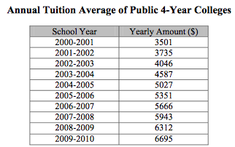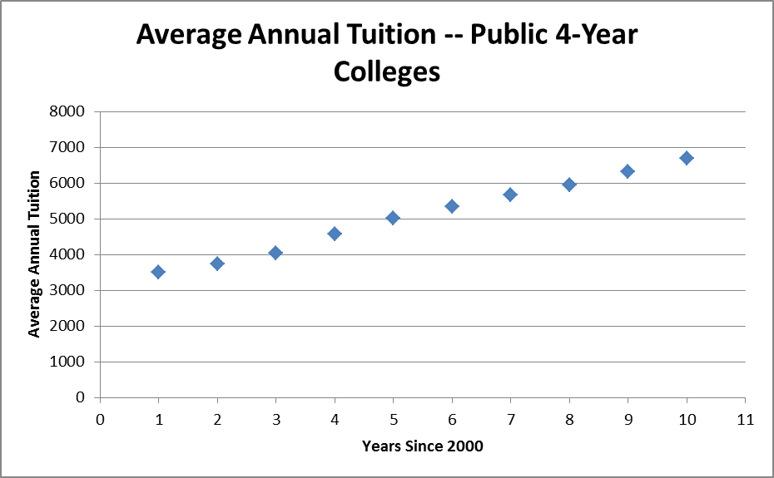

Suppose the data for the average tuition amounts for all 4-year public colleges were used to create a new model equation. Also, suppose this model equation was used to predict your future college tuition amounts for the 4-yr public college you selected.

1. Which model equation would have a higher correlation factor, the one created from the average tuition amounts or the model equation you created from the tuition amounts at the college you selected?
   1. Find the model equation for the average annual tuition data.
2. Do you think it would be helpful or misleading to provide the model equation created from the average tuition on the College Board website for families to approximate their future costs? Explain your reasoning.

**Part 4:**

In this last part of the task, you will predict the total tuition amount someone in a future generation will be expected to pay.

Use one of your model equations for tuition at ________________ to predict the total tuition amount for a family that has a child born 10 years from now. You should assume that this child will:

• attend the school you selected,

• begin college at age 18, and

• attend for the full length of time (4 years).

**1.** Show how you determined the predicted total college tuition amount for this person. You may use a combination of diagrams, mathematical expressions/equations, and words.

**2.** Consider the two articles, “Tuition Hikes of the Downturn” and “The State of the Union on college costs,” you read. Use these articles to help justify why predicting college tuition costs too far into the future, beyond a few years, might not be reliable. Cite information from each article that supports your reasoning.